Reflections on the year,
from CEO Katie Eastaugh
It has been another busy year in the woods. Tough, challenging and on occasion frustrating but always rewarding. Here are a few highlights.

Young Cart Shed
At first glance, an email from a parent saying their son didn’t want to come to The Cart Shed may seem like a setback. In reality, it marked a remarkable success. This young person had spent the last two years of Primary School struggling with severe anxiety, leading to disengagement and isolation. The Cart Shed has been a vital part of his journey, helping him build confidence and resilience. By the time High School began, he no longer needed the reserved place. He was attending school willingly, engaging in learning and had made friends. A truly heartwarming outcome and one of many examples of success over the last 12 months.

Progressions start small – joining a small group and playing a game, talking to an adult or other young person or trying and succeeding in doing something new. From these small steps, confidence grows. Young people learn to recognise their emotions, ask for appropriate adaptations and find strategies to live well. This is early intervention at its best. Support a young person to find resilience and they take those skills into adulthood preventing them from enduring lifelong poor mental health.

Working in Partnership

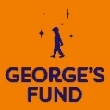
Georges Fund We hosted a day in March on behalf of Georges Fund for organisations who had, like us, received funding to support young people in Herefordshire. It was a fabulous opportunity to share experience and celebrate the work being undertaken across the County.

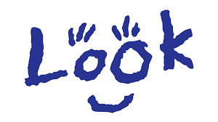
Look UK In October half term we hosted a group of young people with impaired vision from the national charity Look UK. They had a fabulous day in the woods building dens, playing games and making willow trays.
“The day enabled A (and me) to be a part of an activity that was focused to be supportive of their needs. He and I felt included and not the odd ones out or that we had to behave in ways to fit in with others.”
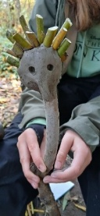
HVOSS UKSPF People and Skills Partnership. Enabling people to find meaning, purpose and a future through improved mental health is key to our work. As part of the UKSPF funded HVOSS People and Skills collaborative partnership fund we enabled 25 participants achieve qualifications and move towards employment and volunteering.
Facts and Figures from 2025
- £558,241 Cost to deliver the service.
- Supporting on average 120 people every week
- 4,848 sessions delivered in 2025
- 22,512 contact hours working directly with participants in the woods.
- 8,500 volunteer hours: Driving, cooking, supporting participants, data analytics, site maintenance.
- 69 volunteers supporting us at least one day a week.

Mental Health and Neurodivergence.
Neurodivergence is a growing theme of our programmes as it is clear many of the adults we support may be undiagnosed. Their mental health has suffered because they have lived much of their lives feeling different and isolated.
“I used a whittling knife for the first time ever in my life today. I am 63. Loved it”.

We continue to develop and adapt the programmes we offer for those who have a diagnosis of, or identify as, Autistic or ADHD/AuDHD. Feedback from participants often expresses the joy of realising they are not broken or bad. People have made new friends, found employment, advocated for themselves and enabled family to understand how and why they view the world a little differently.
“lifechanging, inspiring, uplifting and hopeful”.

Parents and grandparents attending Different not Less (our programme for parents of Autistic children, of any age) report how beneficial the course has been. Parenting a neurodivergent child is often overwhelming, exhausting, isolating and sometimes frightening. The team running Different not Less are there to hold, support and reassure whilst also giving practical advice and solutions.
How we are funded
The Cart Shed does not receive NHS funding for its mental health programmes. Our work is made possible through grants, private donations, fundraising efforts, and support from trusts and foundations. We extend our sincere thanks to everyone who contributed in 2025; we couldn’t do it without you!
CAN YOU HELP?
Adopting The Cart Shed as your Charity of the Year
If you would you like to adopt The Cart Shed as your charity for 2026, please get in touch for the ways you might be able to help us. info@thecartshed.co.uk Corporate and individual sponsorship opportunities of any size are most welcome! We are grateful to all our business sponsors in 2025.

Esse Stoves
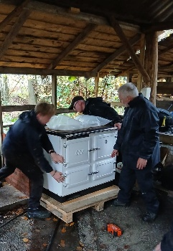
On the 14th November, as storm Claudia was raging, we took possession of a truly fabulous donation from Esse stoves. This will give our volunteer cooks a more reliable heat source on which to make soup and cook sausages for anything up to 30 participants, volunteers and staff on a daily basis. Thanks too to Midtherm for the supply of Flue pipe and Paul from OakTree stoves for the installation.

Charlton and Jenrick
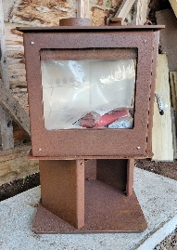
We have also received a fabulous ‘Panofire Eco Stove’ from Charlton and Jenrick for the polytunnel site. This along with the Esse stove will resolve the challenge of cooking over smoking fires and will reduce our fuel consumption significantly.

Volunteering
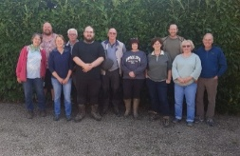
Our team of 69 dedicated volunteers support us daily by cooking, driving participants to and from The Cart Shed, maintaining the sites and turning their hands to, well, anything! We would be nothing without our volunteers – thank you everyone. For full details of how to get involved please take a look at the website.

KindLink
If you would like to support The Cart Shed, you can make a donation via our KindLink page: www.kindlink.com/fundraising/The-Cart-Shed-Charity/support-the-cart-shed or set up your
own fundraising page on the platform: Marathons, sponsored walks, office bring and buy, pyjamas in the office…
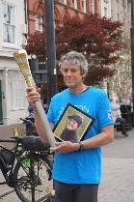
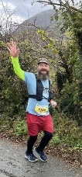
Our Chair David Hunt taking part in the Baton of Hope in Hereford in memory of his daughter Philly.
TCS Tutor Dr Oli running the Eryri (Snowdonia) marathon, jointly raising £2,026 for The Cart Shed.
“I love making connections with new people and making friends, laughing is great for the mind too”.
Coming in 2026…

The Green Dragon Hotel Hereford
During 2026, the Green Dragon is adopting The Cart Shed as its Charity of the Year.

January 23rd-25th Forging Connections. An exhibition of woodcraft and forged metal items created by students at Hereford College of Art and participants at The Cart Shed.
The exhibition celebrates the end of a three-month Cultural Programming project funded from the UK Government through the UK Shared Prosperity Fund. Which has created six sustainable mobile forges and delivered nine days of creativity in the woods. On Sunday 25th students will be demonstrating their skills in the car park at the rear of the hotel.

Look out for our Green Dragon events taking place during the year: Afternoon tea at Easter; A talk by Monty Don in the autumn; Christmas Craft Fair and workshops in November; items for sale year-round made by volunteers and participants. Call in for one of the Cart Shed ‘specials’ on their menu marked with our logo!

Spring Plant Fair
Wednesday 29th April 2026
10.30am – 4pm Garnons, Hereford HR4 7JX
For plant lovers, garden enthusiasts and lovers of parkland trees – see our website for more information.
